Definiciones:

CLASS

METHOD or message

FIELD or attribute

OBJECT or instance

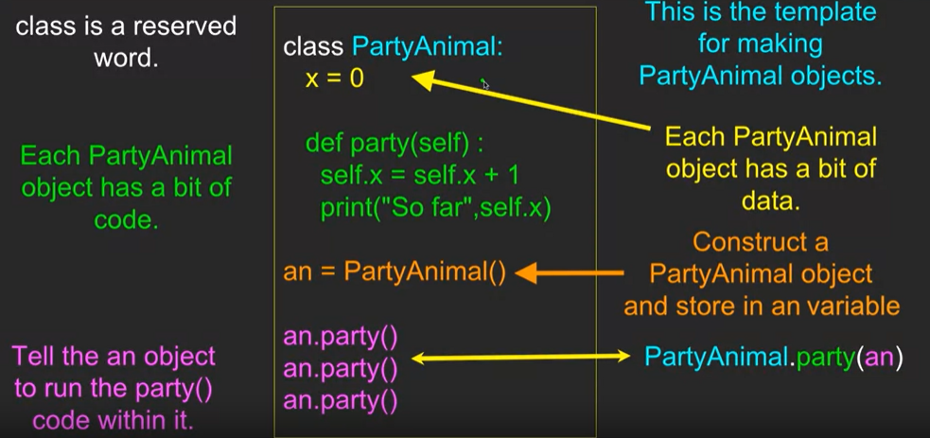

We use the class keyword to define the data and code that will make up each of the objects. The class keyword includes the name of the class and begins an indented block of code where we include the attributes (data) and methods (code). Each method looks like a function, starting with the def keyword and consisting of an indented block of code. This object has one attribute (x) and one method (party). The methods have a special first parameter that we name by convention self. Just as the def keyword does not cause function code to be executed, the class keyword does not create an object. Instead, the class keyword defines a template indicating what data and code will be contained in each object of type PartyAnimal.

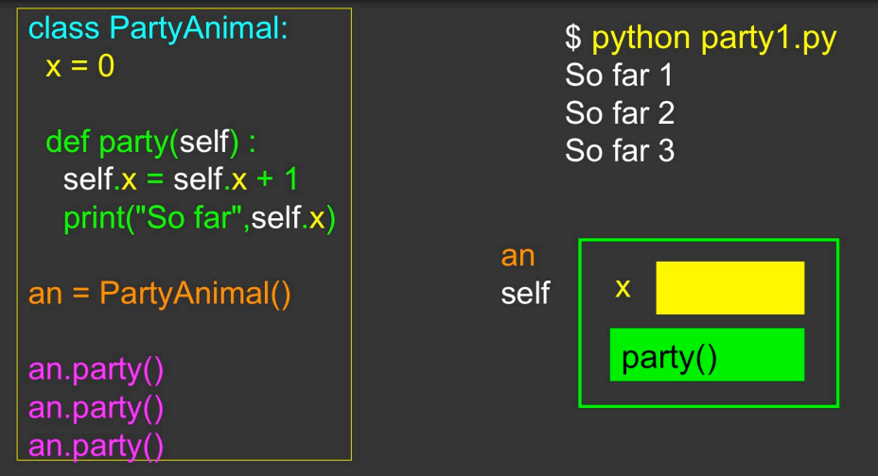

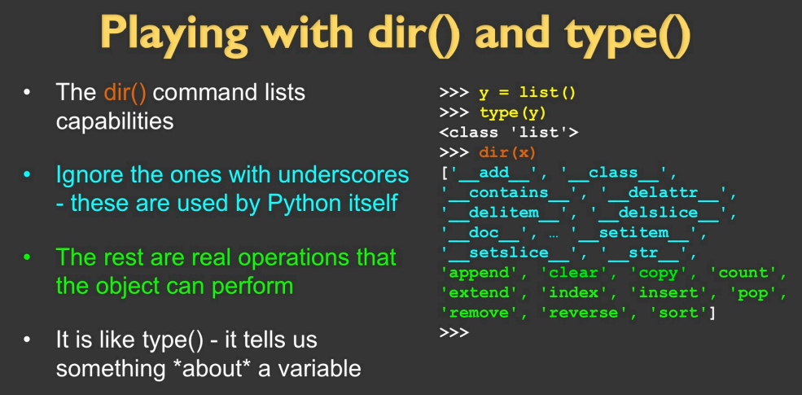

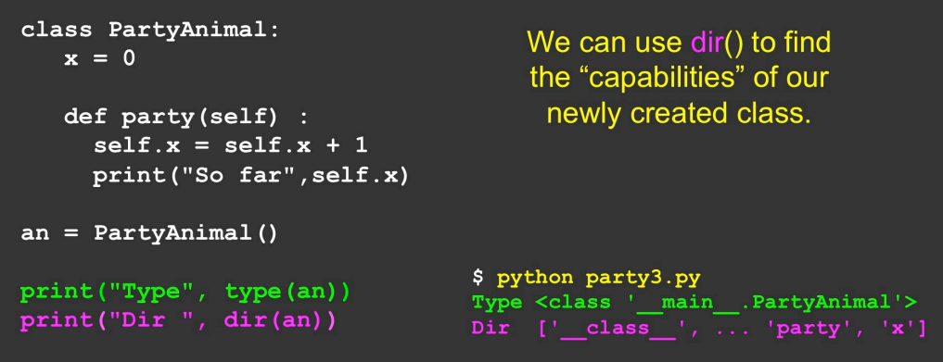

Los objetos tienen un CICLO DE VIDA y también existe algo que se llama INHERIT, donde las capacidades de una clase pueden agregarte a otra. <https://www.py4e.com/html3/14-objects>